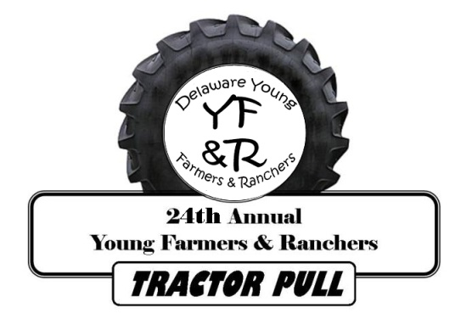
REGISTRATION FORM

To participate, all registration forms and entry fees must be received by
the Farm Bureau office by Friday, July 14th (See tractor pull rules & regulations)

Date: Saturday, July 28, 2018

Weigh in Time: 9:00am – 10:00am

Time: 11:00am
*Drivers’ meeting at 10:30 am*

Location: The Delaware State Fairgrounds – QUILLEN ARENA
18500 South DuPont Highway
Harrington, DE 19952

Entry Cost: $20.00 Per Hook / 3 Hooks Pull Per Tractor

Please mail this completed registration form with your release form and payment to:
Delaware Farm Bureau
3457 South DuPont Highway
Camden, Delaware 19934
Attn: Antique Tractor Pull

Registration Information:

Name:

Address:

City: State: ZIP:

Phone: Secondary Phone:

Tractor Make: Year: Model:

Class:___________________________________________________________________________

________________________________________________________________________________

________________________________________________________________________________

________________________________________________________________________________

