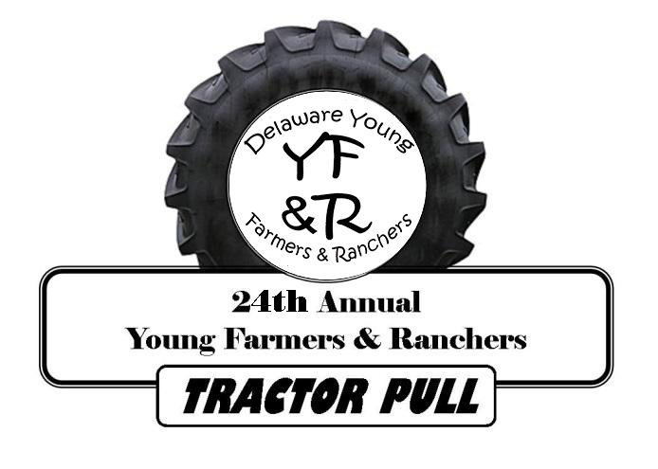
YOUNG FARMERS
& RANCHERS
Delaware State Farm Bureau, Inc.
3457 S. DuPont Highway
Camden, Delaware 19934
- 697-3183 or 1-800-273-0012

RELEASE FORM

Please return this completed form with your registration and payment.

Event Information: Young Farmers & Ranchers Antique Tractor Pull

Date: Saturday, July 28, 2018

Time: 11:00am

Location: The Delaware State Fairgrounds – QUILLEN ARENA
18500 South DuPont Highway
Harrington, DE 19952

By signing this release form, I understand and agree that the Young Farmers and Ranchers Committee of the Delaware Farm Bureau, Inc., The Delaware State Fair, Inc., the sled owner/operator, and/or any event staff, will not be held liable in any way, if by chance I were to be injured or suffer equipment damage during this event.

Signature

There will be a drivers’ meeting Saturday, July 28 at 10:30 AM, at the office.

